SEC Form 4
FORM 4 |  | UNITED STATES SECURITIES AND EXCHANGE COMMISSION  Washington, D.C. 20549  STATEMENT OF CHANGES IN BENEFICIAL OWNERSHIP  Filed pursuant to Section 16(a) of the Securities Exchange Act of 1934  or Section 30(h) of the Investment Company Act of 1940
  OMB APPROVAL
  OMB Number: | 3235-0287
  Estimated average burden
  hours per response: | 0.5
 | Check this box if no longer subject to Section 16. Form 4 or Form 5 obligations may continue. See Instruction 1(b).
 | Check this box to indicate that a transaction was made pursuant to a contract, instruction or written plan for the purchase or sale of equity securities of the issuer that is intended to satisfy the affirmative defense conditions of Rule 10b5-1(c). See Instruction 10.
1. Name and Address of Reporting Person*  (Street) | 2. Issuer Name and Ticker or Trading Symbol  Goosehead Insurance, Inc. [ GSHD ]  Foreign Trading Symbol | 5. Relationship of Reporting Person(s) to Issuer  (Check all applicable)
  KEBODEAUX ADRIENNE
  (Last) | (First) | (Middle)
  C/O GOOSEHEAD INSURANCE, INC.
  1500 SOLANA BLVD., BLDG 4, STE 4500
  WESTLAKE | TX | 76262
  (City) | (State) | (Zip)
   | Director |  | 10% Owner
   | Officer (give title below) |  | Other (specify below)
  Member of 10% owner group
3. Date of Earliest Transaction (Month/Day/Year)
07/28/2026
 | 4. If Amendment, Date of Original Filed (Month/Day/Year) | 6. Individual or Joint/Group Filing (Check Applicable Line)
  Form filed by One Reporting Person
  Form filed by More than One Reporting Person
Table I - Non-Derivative Securities Acquired, Disposed of, or Beneficially Owned
1. Title of Security (Instr. 3) | 2. Transaction Date (Month/Day/Year) | 2A. Deemed Execution Date, if any (Month/Day/Year) | 3. Transaction Code (Instr. 8) |  | 4. Securities Acquired (A) or Disposed Of (D) (Instr. 3, 4 and 5) |  |  | 5. Amount of Securities Beneficially Owned Following Reported Transaction(s) (Instr. 3 and 4) | 6. Ownership Form: Direct (D) or Indirect (I) (Instr. 4) | 7. Nature of Indirect Beneficial Ownership (Instr. 4)
1. Title of Security (Instr. 3) | 2. Transaction Date (Month/Day/Year) | 2A. Deemed Execution Date, if any (Month/Day/Year) | Code | V | Amount | (A) or (D) | Price |  | 6. Ownership Form: Direct (D) or Indirect (I) (Instr. 4) | 7. Nature of Indirect Beneficial Ownership (Instr. 4)
Class B Common Stock | 07/28/2026 |  | C |  | 5,000 | D | $0 | 280,027 | D
Class A Common Stock | 07/28/2026 |  | C |  | 5,000 | A | $0 | 5,000 | D
Class A Common Stock | 07/28/2026 |  | S |  | 5,000 | D | $65.2(1) | 0 | D
Class B Common Stock |  |  |  |  |  |  |  | 63,530 | I | Chick & The Bear Irrevocable Trust(2)
Table II - Derivative Securities Acquired, Disposed of, or Beneficially Owned
(e.g., puts, calls, warrants, options, convertible securities)
1. Title of Derivative Security (Instr. 3) | 2. Conversion or Exercise Price of Derivative Security | 3. Transaction Date (Month/Day/Year) | 3A. Deemed Execution Date, if any (Month/Day/Year) | 4. Transaction Code (Instr. 8) |  | 5. Number of Derivative Securities Acquired (A) or Disposed of (D) (Instr. 3, 4 and 5) |  | 6. Date Exercisable and Expiration Date (Month/Day/Year) |  | 7. Title and Amount of Securities Underlying Derivative Security (Instr. 3 and 4) |  | 8. Price of Derivative Security (Instr. 5) | 9. Number of derivative Securities Beneficially Owned Following Reported Transaction(s) (Instr. 4) | 10. Ownership Form: Direct (D) or Indirect (I) (Instr. 4) | 11. Nature of Indirect Beneficial Ownership (Instr. 4)
 |  |  |  | Code | V | (A) | (D) | Date Exercisable | Expiration Date | Title | Amount or Number of Shares
LLC Units in Goosehead Financial, LLC | $0 | 07/28/2026 |  | C |  |  | 5,000 | (3) | (3) | Class A Common Stock | 5,000 | $0 | 280,027 | D
LLC Units in Goosehead Financial, LLC | $0 |  |  |  |  |  |  | (3) | (3) | Class A Common Stock | 63,530 |  | 63,530 | I | Chick & The Bear Irrevocable Trust(2)
Explanation of Responses:
1. The price reported in Column 4 is a weighted average price. These shares were sold in multiple transactions at prices ranging from $65.02 to $65.52, inclusive. The reporting person undertakes to provide to the issuer, any security holder of the issuer, or the staff of the Securities and Exchange Commission, upon request, full information regarding the number of shares sold at each separate price within the range set forth in this footnote to this Form 4.
2. Reflects shares of Class A Common Stock, shares of Class B Common Stock, or LLC Units, as applicable, held (a) directly by the Chick & The Bear Irrevocable Trust and (b) indirectly by Adrienne Kebodeaux, who serves as trustee of the Chick & The Bear Irrevocable Trust and whose immediate family members are beneficiaries of the Chick & The Bear Irrevocable Trust.
3. Each LLC Unit, together with a share of Class B Common Stock, may be converted by the holder into one share of Class A Common Stock at any time. The LLC Units do not expire.
Remarks:
 | /s/ Martin Thornthwaite, as Attorney-in-Fact for Adrienne Kebodeaux | 07/30/2026
 | ** Signature of Reporting Person | Date
Reminder: Report on a separate line for each class of securities beneficially owned directly or indirectly.
* If the form is filed by more than one reporting person, see Instruction 4 (b)(v).
** Intentional misstatements or omissions of facts constitute Federal Criminal Violations See 18 U.S.C. 1001 and 15 U.S.C. 78ff(a).
Note: File three copies of this Form, one of which must be manually signed. If space is insufficient, see Instruction 6 for procedure.
Persons who respond to the collection of information contained in this form are not required to respond unless the form displays a currently valid OMB Number.
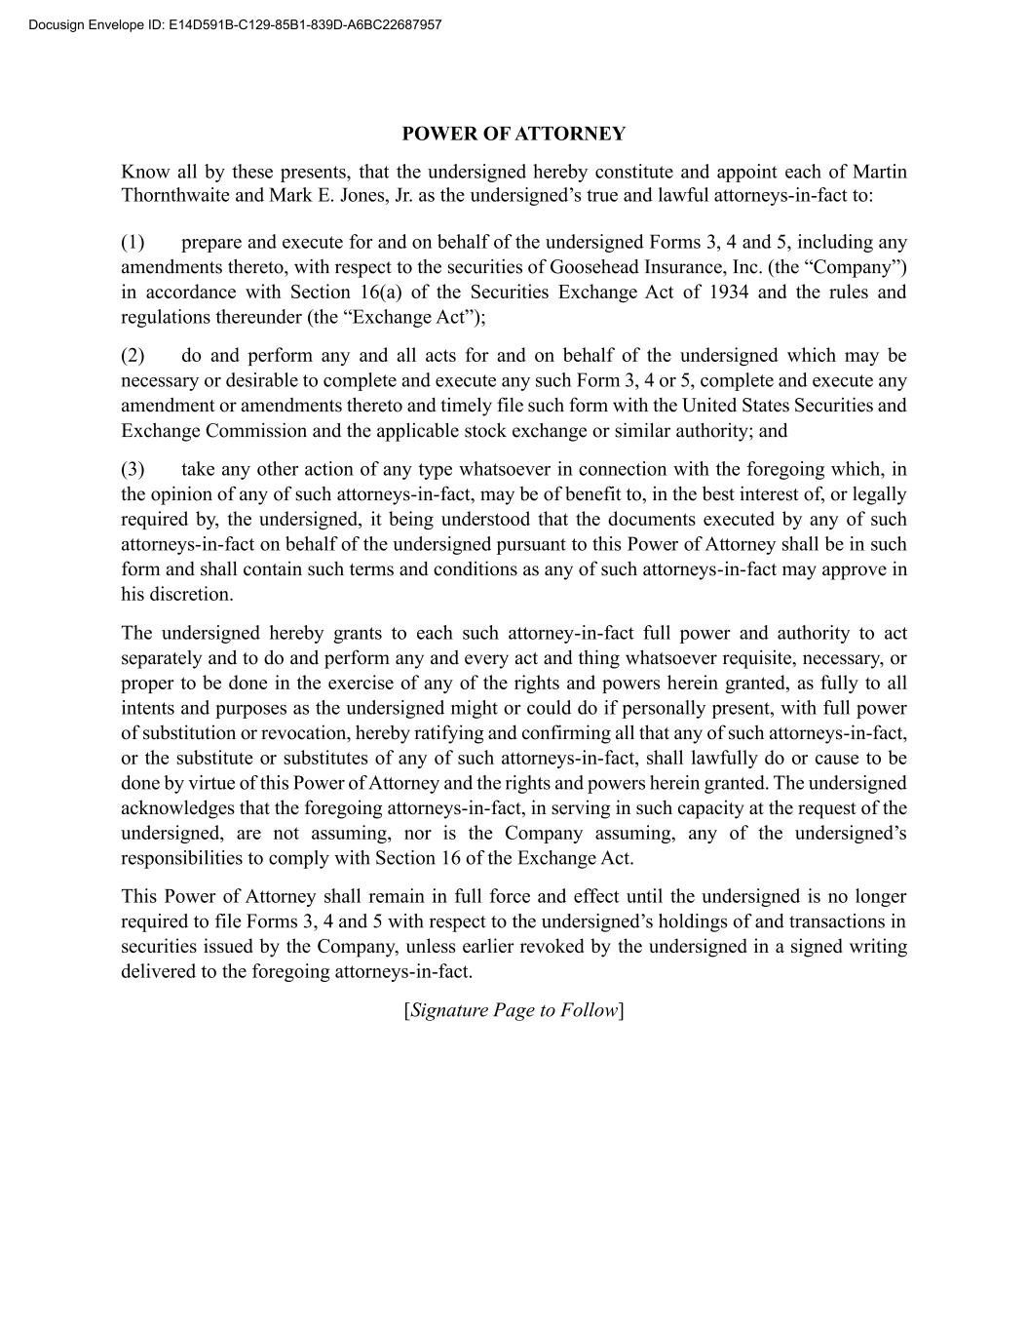
POWER OF ATTORNEY Know all by these presents, that the undersigned hereby constitute and appoint each of Martin Thornthwaite and Mark E. Jones, Jr. as the undersigned’s true and lawful attorneys-in-fact to: (1) prepare and execute for and on behalf of the undersigned Forms 3, 4 and 5, including any amendments thereto, with respect to the securities of Goosehead Insurance, Inc. (the “Company”) in accordance with Section 16(a) of the Securities Exchange Act of 1934 and the rules and regulations thereunder (the “Exchange Act”); (2) do and perform any and all acts for and on behalf of the undersigned which may be necessary or desirable to complete and execute any such Form 3, 4 or 5, complete and execute any amendment or amendments thereto and timely file such form with the United States Securities and Exchange Commission and the applicable stock exchange or similar authority; and (3) take any other action of any type whatsoever in connection with the foregoing which, in the opinion of any of such attorneys-in-fact, may be of benefit to, in the best interest of, or legally required by, the undersigned, it being understood that the documents executed by any of such attorneys-in-fact on behalf of the undersigned pursuant to this Power of Attorney shall be in such form and shall contain such terms and conditions as any of such attorneys-in-fact may approve in his discretion. The undersigned hereby grants to each such attorney-in-fact full power and authority to act separately and to do and perform any and every act and thing whatsoever requisite, necessary, or proper to be done in the exercise of any of the rights and powers herein granted, as fully to all intents and purposes as the undersigned might or could do if personally present, with full power of substitution or revocation, hereby ratifying and confirming all that any of such attorneys-in-fact, or the substitute or substitutes of any of such attorneys-in-fact, shall lawfully do or cause to be done by virtue of this Power of Attorney and the rights and powers herein granted. The undersigned acknowledges that the foregoing attorneys-in-fact, in serving in such capacity at the request of the undersigned, are not assuming, nor is the Company assuming, any of the undersigned’s responsibilities to comply with Section 16 of the Exchange Act. This Power of Attorney shall remain in full force and effect until the undersigned is no longer required to file Forms 3, 4 and 5 with respect to the undersigned’s holdings of and transactions in securities issued by the Company, unless earlier revoked by the undersigned in a signed writing delivered to the foregoing attorneys-in-fact. [Signature Page to Follow] Docusign Envelope ID: E14D591B-C129-85B1-839D-A6BC22687957

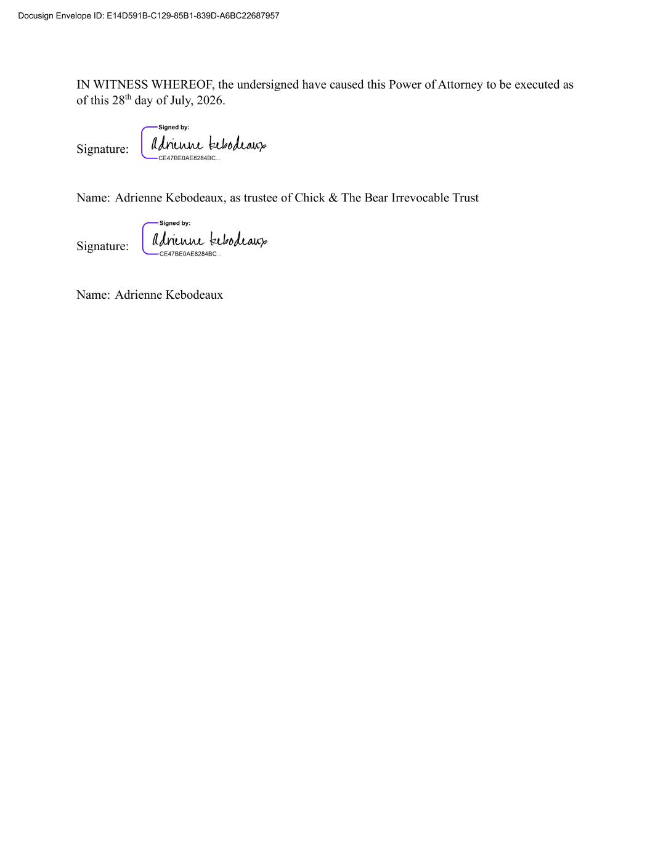
IN WITNESS WHEREOF, the undersigned have caused this Power of Attorney to be executed as of this 28th day of July, 2026. Signature: Name: Adrienne Kebodeaux, as trustee of Chick & The Bear Irrevocable Trust Signature: Name: Adrienne Kebodeaux Docusign Envelope ID: E14D591B-C129-85B1-839D-A6BC22687957

